Node js deployment screenshot

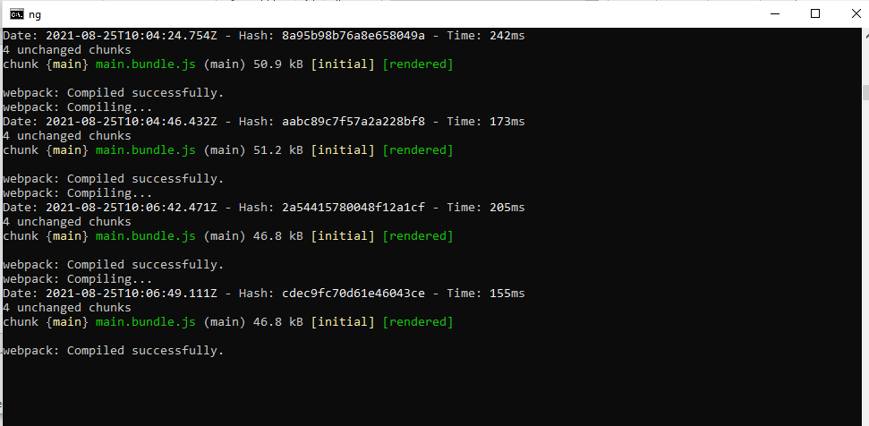

Database-mysql screenshots

